Education

Chelsea Haith
Mobile: +447554982819
Email: haith.chelsea@gmail.com
Twitter: @chelsea_haith
Website: www.chelseahaith.com
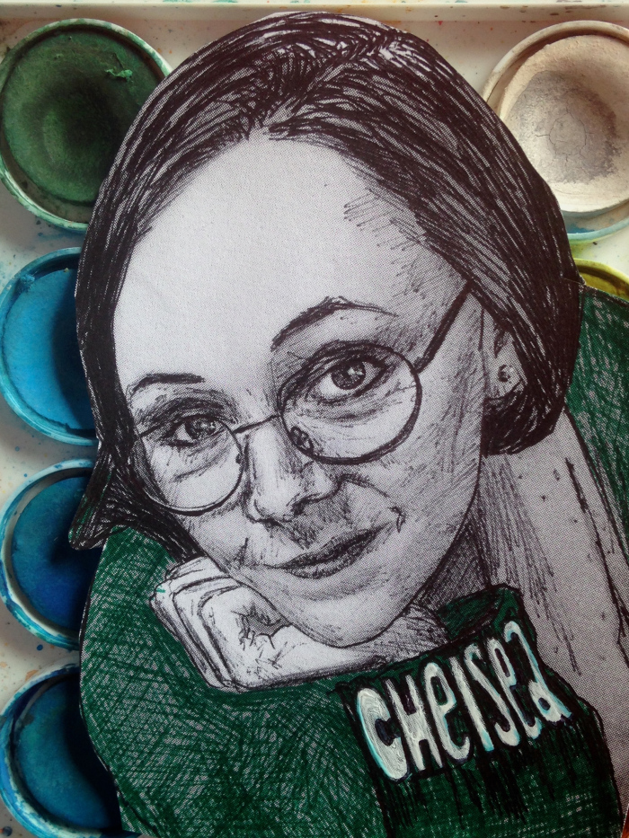
2018-2021 Doctor of Philosophy (DPhil) candidate, Faculty of English, University of Oxford.
Thesis: “Anxieties of Time: Urban Dystopia in Contemporary Speculative Fiction”
2017-2018 Master of Arts in Culture and Thought after 1945, University of York (first class). Specialised in: ‘Debating Global Literary Culture 1800 – present’; ‘Neoliberalism and its Discontents’; ‘Women, Citizenship and Conflict’; and ‘Framing the Contemporary’.
2017 Bachelor of Social Science Honours,
University of Cape Town (with distinction)
2016 Bachelor of Arts Honours in English Literature,
Rhodes University (with distinction)
2013-2015 Bachelor of Arts undergraduate majoring in English Literature, French Studies, and Journalism & Media Studies, Rhodes University (with distinction). Minors in Linguistics, Intro to Philosophy, Modern Fiction and isiXhosa for Journalism.

Relevant Experience
2019-2021
- Futures Thinking Founder
  - Wrote the successful grant funding bid to initiate this network at Oxford University.
  - Designed the network’s branding and co-wrote the manifesto and ethics statement regarding our policies on inclusion and diversity.
  - Developed clearly defined goals and implemented a strategy to achieve the network’s intended outcome: engagement of approximately 500 people in seminar events, and over 2000 online engagements across platforms. Achieved this and more over two years of operations.
  - Collaborated with my team to conceptualise, advertise and execute a three-day international academic conference. As team leader I managed databases, controlled budget and project management, handled communications and copy writing, concept design, and networked our key note speakers (Marcus du Sautoy and Alex Goody).
  - Created three multimedia research engagement projects: Conceptualised and edited Speculation & Percolation, produced the Will Machines Make Us Laugh? video series and researched, wrote, recorded, and edited the Narrative Futures podcast.
2018-2020
- Research and Development Manager at social enterprise Uncomfortable Oxford
  - Lead a small team to make academic research comprehensible and accessible to a less expert audience. Wrote engaging content for public and online presentation.
  - Pioneered the Uncomfortable Oxford Literary Tour. This sold out during the IF Festival and consequentially I was interviewed on BBC Oxford and featured in OX Magazine.
- WordPress Specialist Volunteered at Africa in Dialogue
  - Redesigned the archive project’s brand design and built the site’s web presence.
- Associate Reviews Editor at Africa in Words
  - Managed a publishing schedule, liaised with publishers and reviewers, managed multiple project timelines, wrote reviews maintaining the organisation’s branding policy.
2014-2017
- Freelance journalist covering social justice pieces and the arts:
- SA Music Scene: https://samusicscene.co.za/wp/author/chelsea-haith/
- The Journalist:
  - http://www.thejournalist.org.za/spotlight/enough-is-kwanele-for-gay-pride/
  - http://www.thejournalist.org.za/kau-kauru/universities-must-disrupt-the-system/
  - http://www.thejournalist.org.za/art/free-art-space-connects-people/
  - http://www.thejournalist.org.za/art/intlangano-complicating-masculinity-through-dance/
  - http://www.thejournalist.org.za/spotlight/violence-nakedness-and-the-discourse-of-rureferencelist/
- Africa is a Country: https://africasacountry.com/2015/10/how-to-report-on-the-student-protests-in-south-africa
- Rhodes University Communications: Wrote university brand specific copy for online and in-print publications.

Other

Professional Development and General Skills
- Introduction to Strategic Planning short course, covering Business Model Canvas and Theory of Change, hosted by the Careers Service at Oxford, 2021.
- Introduction to Web Programming, four-week course hosted by the Oxford Code Lab, 2021.
- DBS certificate updated on 26 August 2020.
- Mental Health First Aid Champion certificate (MHFAE accredited), 2019.
- Podcasting for Public Engagement, Oxford, course certificate, 2019.
- How to Run a Conference short course certificate, 2019.
- Delf Exams (French B2) certificates, 2015.
- British Driver’s License (converted from South African Driver’s License in 2019)
- Excellent skills in the Microsoft Office suite, particularly Excel and PowerPoint.
- Good skills in audio and video editing using Audacity and Adobe Premier Pro.
- Languages:
  - English (mother-tongue, proficiency excellent)
  - French (2nd language, proficiency good)
  - Afrikaans (3rd language, proficiency good)

Other professional experience
- Data collector, No Offence exhibition, Ashmolean Museum (November 2018).
- Social media manager of Postcolonial Writing and Theory Seminar at the University of Oxford.@PocoSeminarOx: +1000 followers. (October 2018 to present)
- Research Assistant on the Prismatic Translation project which is part of the larger Creative Multilingualism grant (January to April 2019).
- Drafted the conference Call for Papers and built the website for the Oxford Graduate Conference (January to June 2019).
- Communications Officer, English Graduates of Oxford (EGO) (2018/2019)
- Editor, WRoCAH Journal, a postgraduate academic journal for the White Rose College of the Arts and Humanities (2017/2018)
- Paid internship at uHlanga Press, an independent poetry publisher based in Cape Town, working with Nick Mulgrew (2017).
- Fundraiser and Pub Quiz Writer, University of York Graduate Students Association (2017-2018)
- Narrator, South African Library for the Blind (2014-2016).
- Marshall, Silent Protest against gender based violence at Rhodes University (2013, 2014, 2016)
- Media Officer, Gender Action Project (2016).
- Submissions Manager, Type/Cast (2016/2017)
- Student Representative, Sexual Violence Task Team (2016)
- Paid-internship at Penguin Random House South Africa, (January 2015)
- Online Editor and Mentor, The Oppidan Press student newspaper at Rhodes University (June 2013 to December 2014)

Scholarships, Awards and Grants
- Oppenheimer Memorial Trust scholarship for DPhil at the University of Oxford – 2018-2021
- Skye Foundation Scholarship for DPhil at the University of Oxford – 2018-2021
- Centre for Modern Studies scholarship for MA at the University of York – 2018/2019
- Patrick and Margaret Flanagan Scholarship for MA at the University of York – 2018/2019
- Mandela Rhodes Scholarship for BSocSci Honours at the University of Cape Town – 2017
- Oxford University Press Prize, awarded to the top achieving student in the BA Honours in English Literature programme at Rhodes University – 2016
- Dr Kendall Scholarship: full funding for a BA Honours in English Literature at Rhodes University awarded to the top achieving undergraduate student in English – 2015
- Dr Valentine Cuenod Memorial Prize, awarded to the top achieving undergraduate student in French Studies – 2015
- Dr Kevin Carlean scholarship, awarded to the top achieving second year student in Journalism & Media Studies – 2014
- Mother Florence Trophy, awarded to the top achieving first year student across all disciplines at Rhodes University – 2013
- Dean’s List and Academic Honours awarded annually – 2013-2016.

References on request

